Department of Computer Science and Engineering
Lab Report
Lab Report No | : | 05
Lab Report Name | : | Newton-Raphson Method. F(x)= 3x-cos(x)-1.
Course Title | : | Numerical Methods Sessional
Course Code | : | CSE 226
Name | : | Gazi Rishad Kaiser
ID | : | 1120047
Level | : | 2 | Term | : | 2 | Section | : | A | Group | : | 2
Date of Submission | : | -2026 | Semester | : | Spring | Year | : | 2026

Key Learnings:
- The Newton-Raphson method was used to find the root of a nonlinear equation through successive iterations. It demonstrated how an approximate solution can be improved step by step.
- The experiment showed that the accuracy of the result depends on the initial guess and the correct evaluation of the function and its derivative.
Problem-01: Newton-Raphson Method. F(x)= 3x-cos(x)-1.
Source Code: Input & Output:
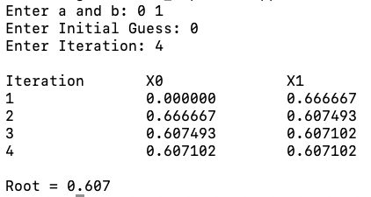
#include<iostream>
#include<iomanip>
#include<cmath>
using namespace std;
double f(double x){
return 3*x-cos(x)-1;
}
double df(double x){
return 3+sin(x);
}
int main(){
double a,b,x0,x1;
int n;
cout<<"Enter a and b: ";
cin>>a>>b;
if(f(a)*f(b)>=0){
cout<<"Invalid Input"<<endl;
return 0;
}
cout<<"Enter Initial Guess: ";
cin>>x0;
cout<<"Enter Iteration: ";
cin>>n;
cout<<"\nIteration\tX0\t\tX1\n";
for(int i=1;i<=n;i++){
x1=x0-f(x0)/df(x0);
cout<<i<<"\t\t"<<fixed<<setprecision(6)<<x0<<"\t"<<x1<<endl;
x0=x1;
}
cout<<"\nRoot = "<<fixed<<setprecision(3)<<x1<<endl;
return 0;
}%

Result Analysis
The Newton-Raphson method was successfully applied to approximate the root of the given equation. The calculated values became progressively closer to the actual root with each iteration. The convergence of the solution was observed through:
1. A decreasing error between consecutive approximations.
2. A reduction in the value of the function at each step.
3. The stabilization of the root estimate after a few iterations.
The method demonstrated high accuracy and required only a small number of iterations to reach the desired result. The results confirm that the Newton-Raphson method is an effective numerical technique for solving nonlinear equations when an appropriate initial guess is selected.
